Evolution – what is evolution?

Name____________________________________________ Class_____________________

What you will need for this lesson: some rice, a scissors, a fork, a large spoon, a small spoon, some chopsticks or 2 straws, a plate. a bowl and a stopwatch.

You will also need a pen, a pencil and if you have it, access to a computer, tablet or iPad.

The
LESSON STARTER

Evolution is the gradual change of living things over a long period of time. The changes that take place make the living thing stronger and more likely to survive. Some species of animals have not evolved. Why do you think that might be? Here are two such animals:

Why do you think their species have not evolved?

______________________________________________________________________

______________________________________________________________________

______________________________________________________________________

______________________________________________________________________

______________________________________________________________________

______________________________________________________________________


______________________________________________________________________

______________________________________________________________________

______________________________________________________________________

______________________________________________________________________

______________________________________________________________________

______________________________________________________________________

______________________________________________________________________

______________________________________________________________________

______________________________________________________________________

______________________________________________________________________

______________________________________________________________________

______________________________________________________________________

______________________________________________________________________

When you’ve finished, watch the video to find out more!

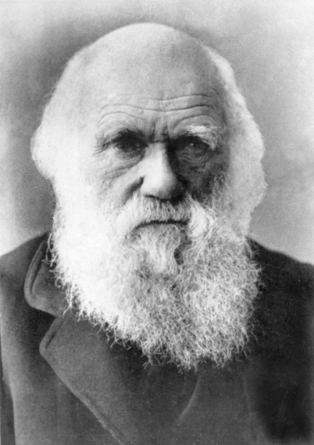
While he was there he noticed that there was one type of bird but a number of these birds different beaks. The size, length and breadth of their beaks differed. He began to wonder why they were all so different. This was the start of Darwin’s theory of evolution.

We are going to replicate Darwin’s study of the different beaks. Follow the method below.
The Investigation

In 1835, Charles Darwin and the crew of HMS Beagle landed on the Galapagos Islands. Darwin started to study the island’s natural life and came up with a theory that would change the way the world thought.

WORKING SCIENTIFICALLY

Our next focus is about working scientifically. All scientists apply these principles whenever they are investigating anything and we’ve divided them into different skill units.

Find the section your teacher has asked you to focus on and answer the questions in the relevant section.

A. Planning or

B. Presenting and analysing data or

C. Evaluation

A. Planning

Every scientist wants to solve a problem and so takes the following steps:
- Decides on a question that needs answering. e.g. Does the size of the food affect which is the best tool to use?
- Decides what the independent variable (the thing that is changed) might be in order to work out the answer to the question e.g. I will change the size of the tool.
- Decides what the dependent variable might be (how to measure the differences in each different example) e.g. I count the amount of food transferred to the plate.
- Last of all decide what elements have to stay the same in order to make it a fair test e.g. I will keep the tools the same.

Now using this knowledge, see if you can answer the questions below!

Years 3, 4, and 5 – Design the question you would ask if the following were your independent and dependent variables.

The Independent variable is the type of tool.

The Dependent variable is the number of rice grains collected.

My question is:

_________________________________________________________________________________

_________________________________________________________________________________

_________________________________________________________________________________

Year 4 and 5: My prediction is:

_________________________________________________________________________________

________________________________________________________________________________

________________________________________________________________________________

Planning continued..

Year 5: Justify your prediction. Why do you think that will happen?

_________________________________________________________________________________________

_________________________________________________________________________________________

_________________________________________________________________________________________

_________________________________________________________________________________________

Year 6

In the space below and on the next page, can you write a complete step by step method so that a stranger could carry out this investigation? You can draw some additional diagrams if it helps you to explain better.

___________________________________________________________________________________

___________________________________________________________________________________________

___________________________________________________________________________________________

___________________________________________________________________________________________

___________________________________________________________________________________

___________________________________________________________________________________________

___________________________________________________________________________________________

___________________________________________________________________________________________

___________________________________________________________________________________

___________________________________________________________________________________________

___________________________________________________________________________________________

___________________________________________________________________________________________

Planning continued..

_________________________________________________________________________________________

_________________________________________________________________________________________

_________________________________________________________________________________________

_________________________________________________________________________________________

___________________________________________________________________________________

___________________________________________________________________________________________

___________________________________________________________________________________________

___________________________________________________________________________________________

___________________________________________________________________________________

___________________________________________________________________________________________

___________________________________________________________________________________________

___________________________________________________________________________________________

___________________________________________________________________________________

___________________________________________________________________________________________

___________________________________________________________________________________________

___________________________________________________________________________________________

___________________________________________________________________________________________

B. PRESENTING & ANALYSING DATA

When scientists carry out investigations, it is really important that they capture data to make sure they can then answer the questions that they have set themselves.
The scientist on the video has asked you to complete the following:

Year 3 pupils – You are carrying out experiments to answer the following question:

Does the type of rice used affect the number of grains collected on the plate?

Think about how you would create a table to show your results? Draw your table in the space at the end of the Presenting and analysing data section and then record your results within it.

Year 4 & 5 pupils – You are carrying out experiments to answer the following question:

Does the mass (weight) of the rice affect the number of rice grains collected on the plate?

Draw a table in the space at the end of the Presenting and analysing data section and then record your results within it.

After you have recorded your data in your table, can you draw a graph to present your data?

Year 6 – Look at the following question:

Does the time to pick the rice affect the number of rice grains collected on the plate?

Draw a table in the space at the end of the Presenting and analysing data section and then record your results within it.

After you have recorded your results, see if you can present your data in a graph of some kind, e.g. bar chart or line graph. There is some squared paper at the end of the Presenting and analysing data section to do this.

Lastly, can you can spot a trend or pattern in your data? Write your ideas below:

_______________________________________________________________________________________

_______________________________________________________________________________________

_______________________________________________________________________________________

_______________________________________________________________________________________

www

PRESENTING & ANALYSING DATA continued

My Table

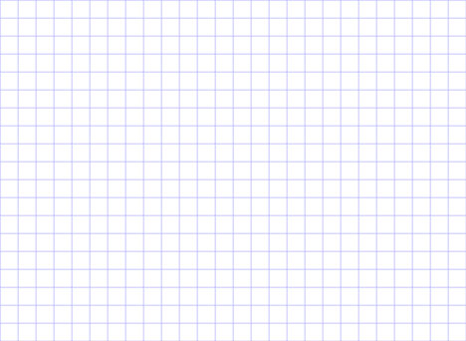

C. EVALUATION

Evaluating how an investigation went as well as the data that comes from a science experiment is a really important part of science. It may be that you feel your experiment could have been done better or more thoroughly and it is important to understand this.

Answer the questions below:

Year 3, 4, 5 and 6 pupils: In your investigations, did you spot a pattern or trend?

_______________________________________________________________________________________

_______________________________________________________________________________________

_______________________________________________________________________________________

Can you see any anomalies or odd results? Circle or underline any you see. If there are none then just say that there weren’t any.
Anomalies are results that stand out because they don’t fit into a pattern.

_______________________________________________________________________________________

_______________________________________________________________________________________

_______________________________________________________________________________________
Year 4,5 and 6 Can you work out why there were any anomalies? Explain below what you think caused those anomalies.

__________________________________________________________________________________

__________________________________________________________________________________
__________________________________________________________________________________
__________________________________________________________________________________

EVALUATION continued

Year 6: Can you think of another experiment that might achieve the same results?

____________________________________________________________________________________

____________________________________________________________________________________

____________________________________________________________________________________

____________________________________________________________________________________

____________________________________________________________________________________
____________________________________________________________________________________

____________________________________________________________________________________

____________________________________________________________________________________

____________________________________________________________________________________

____________________________________________________________________________________

____________________________________________________________________________________

____________________________________________________________________________________

____________________________________________________________________________________

____________________________________________________________________________________

____________________________________________________________________________________


The science behind the investigation

Many species evolve over time. This happens because
the types of features that allow a species to be most
successful in terms of feeding or hunting or defending its
offspring are the ones that will survive. Those features will
be passed on to its offspring and those without the
features will gradually die out.

If a bird feeds on worms that live 6 cm below the surface
of the ground then a bird will need a beak that can
burrow down far enough to lift them out of the ground.
Birds feeding on the same worms with shorter beaks will
eventually die out because they cannot get enough food.
When that happens the only birds left are those with longer
beaks. This was Charles Darwin’s theory of evolution.

.

Your challenge!

Find out about the anteater.
Why does it have such a
long and sticky tongue.

Can you create a
PowerPoint to show what
you have found out?

Do you have a favourite
animal?
Find out any
information about how
that animal or any of its’
features has evolved
over time.

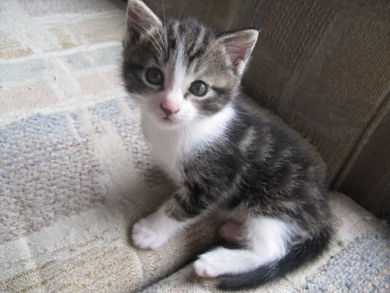
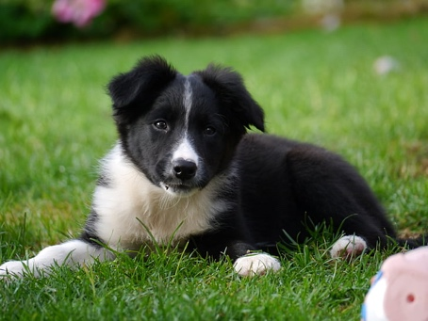
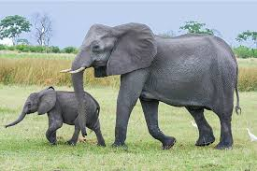

What was your score?

____________________

