
The Music of Africa
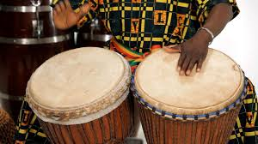
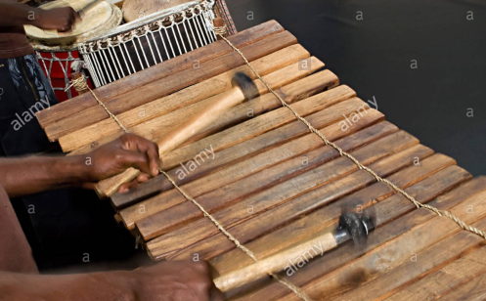
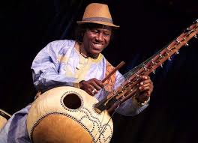



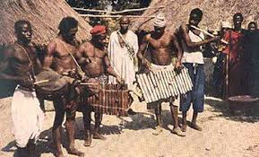
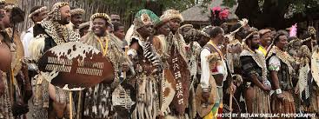

Hello!! Mrs Julier here! I hope you are all safe and well.

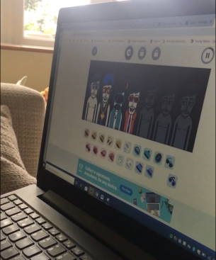
Hope you are all safe and well and have had chance to try out some of the music activities suggested so far. I am hoping some of you managed to try the free version of GarageBand but if not, try and have a go on www.incredibox/demo/ I guarantee it is really fun! You might also be interested to know that Young Voices have created an At Home section on their website and it is free!! Please visit https://www.youngvoices.co.uk/yv-at-home​
Task 1 Warm Up 
Well today we will start with a quick warm up song to get us in the African mood, ‘Jambo Bwana.’ Remember to stand up, try to find the pulse and move from side to side in time with the music. Clap along if you want to. Just don’t sit still! You could even choreograph your own dance moves to it!
https://www.youtube.com/watch?v=kY0VucZrgWA Jambo Bwana
https://www.youtube.com/watch?v=JIPlx1Jk3sY Same song with photos linked to Africa
Now watch the following version of the song which is a bit slower and teaches you how to say the words as well as what they mean. https://www.youtube.com/watch?v=WogvJEfCKpM

Task 2 Try doing the drumming patterns that are on the second video (hands on the back of pans, upside down bin, anything that makes a drum sound!) There is also a section where you can improvise (ie make up your own rhythm pattern on the spot without planning.)
Task 3 Using your ‘drum,’ try the rhythm patterns which the lady teaches in the next clip. You will also need something which you can shake. (Maybe rice or pasta in a v. small sealable box/pot?)
https://www.youtube.com/watch?v=KTXXNLyVRhg SongWorld - Jambo Bwana - Drumming Tutorial
Finale : Now try putting the whole lot together to make a performance. If technology allows, you could even FaceTime, Skype or Zoom a friend or family and share your performance

