
The Music of Africa
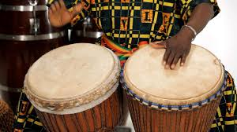
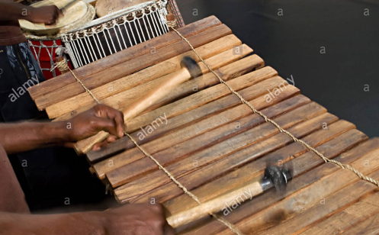
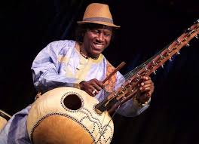

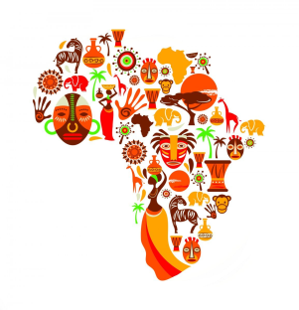

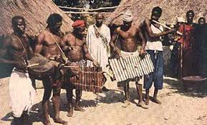
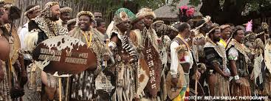

Hello!! Mrs Julier here! I hope you are all safe and well.
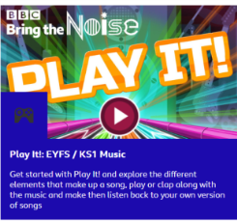

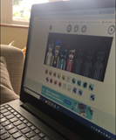
Hope you are all safe and well and have had chance to try out some of the music activities suggested so far. I hope you’ve had chance to go on BBC Teach, Bring the Noise – Play it and create some of your own music. I think you would also enjoy www.incredibox/demo/ I guarantee it is really fun!

Task 1 Warm Up 
Well today we will start with a quick warm up song to get us in the African mood, ‘Jambo Bwana.’ Remember to stand up, try to find the pulse and move from side to side in time with the music. Clap along if you want to. Just don’t sit still! You could even choreograph your own dance moves to it!
https://www.youtube.com/watch?v=kY0VucZrgWA Jambo Bwana
https://www.youtube.com/watch?v=JIPlx1Jk3sY Same song with photos linked to Africa
Now watch the following version of the song which is a bit slower and teaches you how to say the words as well as what they mean. https://www.youtube.com/watch?v=WogvJEfCKpM

Task 2 Try doing the drumming patterns that are on the second video (hands on the back of pans, upside down bin, anything that makes a drum sound.
Task 3 Using your ‘drum’ to try out some of your own rhythm patterns to Jambo. We call this IMPROVISING. If you come across a rhythm that you like and keep repeating in exactly the same way, this means you have now COMPOSED your own rhythm.
Challenge! Can you sing the song AND play your drum? Can you make up some dance moves too? Can you teach these to a family member?
Finale : Now try putting the whole lot together to make a performance. If technology allows, you could even FaceTime, Skype or Zoom a friend or family and share your performance

