Week 2 and Week 3 – KS1 Music
Search BBC Teach KS1 Music and then choose ‘Bring the Noise’
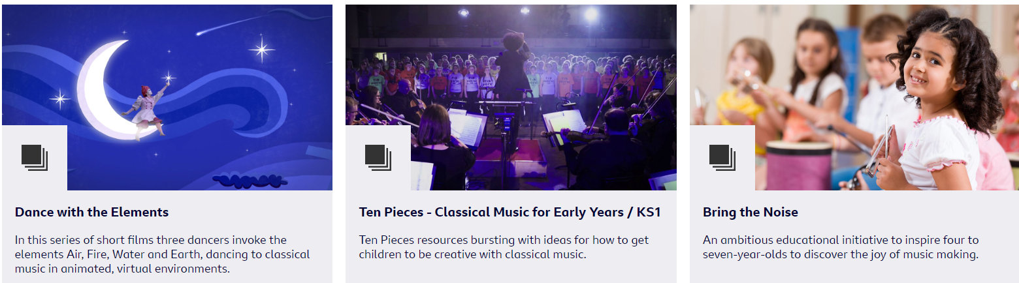
https://www.bbc.co.uk/teach/bring-the-noise
Then select ‘ Bring the Noise Play It’
Your activity is… Explore the different elements that make up a song, play or clap along with the music and listen back to your own versions of the songs.
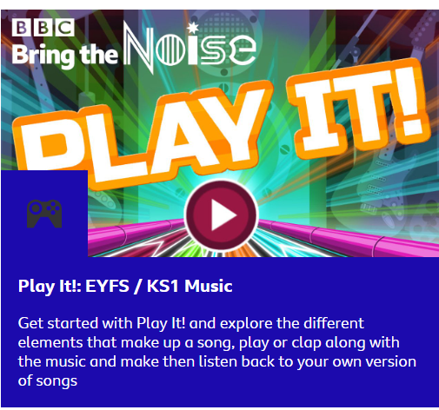
As you scroll further down, you will see the ‘Welcome!’ section followed by Teacher Resources. Download the ‘I am a robot’ lesson. Choose EYFS version if your child is in Red Class and choose the KS1 version if your child is in Orange or Yellow. The objectives of this lesson are to Listen and respond; Moving in time; Creativity and imagination and it is designed to last approx. 25 mins.


