
Learning a Musical Instrument at Bapchild School
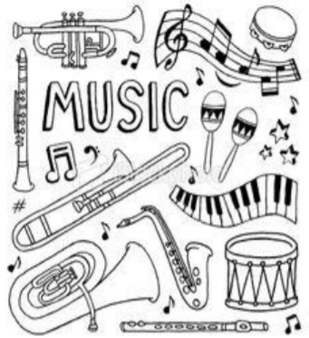
People turn to Music for all manner of reasons, be it for relaxation, a new challenge, celebration or to improve their mental well-being. I’m sure during this unprecedented year, many of us listened to our favourite music in order to relax and escape what was going on. Unfortunately, Covid had a major impact upon instrumental learning because face to face lessons were not permitted for a considerable amount of time. However, we are pleased to inform you that this is no longer the case and would like to encourage children to consider giving instrumental lessons a try.
Benefits of Learning a Musical Instrument
The most important of these has to be enjoyment! There has been lots of research to show that learning an instrument can improve a child’s cognitive abilities across all subjects. This is probably due to a number of factors, including the discipline of practice and perseverance that learning an instrument develops, increased confidence and also right-left brain co-ordination.


Through learning an instrument, children can participate in orchestras, ensembles and concerts,
enabling them to meet and play with children
from other schools and different backgrounds.

What are the costs involved?
Believe it or not, it is possible to learn some instruments for as little as £2.50 for a 30mins lesson. Beginners can hire an instrument for an entire year at very minimal cost instead of buying their own. Flutes/Clarinets are £24 and guitars and violins are just £21 per year. Families in receipt of family working tax credits and/or income support may also be entitled to 75% reduction.
Which instrument?
The question of which instrument to begin on is an important one. Firstly, if your child has a desire to learn a particular instrument, provided it is not physically unsuitable for them (e.g. a saxophone may be too big for a 7 year old) then go with that! Wanting to learn is extremely important!
We currently have tutors who teach violin, flute, clarinet, piano and guitar however, provided we have at least 4 children wanting to take up lessons, we could organise for a brass tutor to start next academic year...

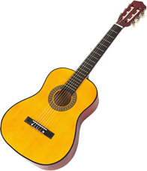
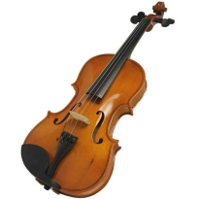
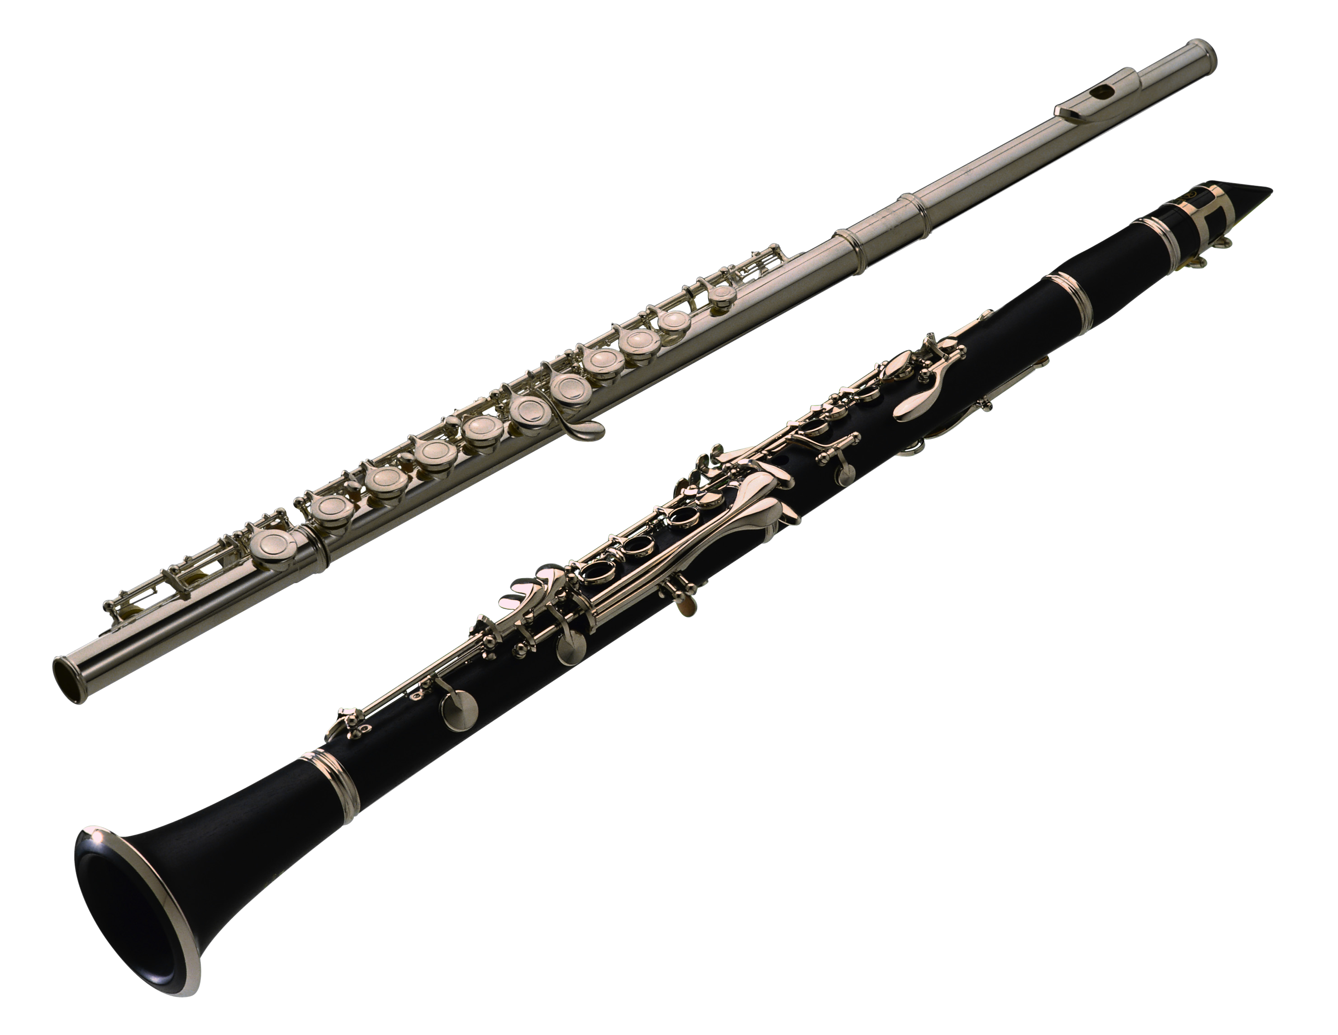
How do I find out more?
If you would like further details, please contact the school office who will then let Mrs Julier know. We will do our best to answer any questions you may have regarding costs, lesson times, instrument choice and we will also contact the relevant instrumental teacher on your behalf. With kind regards Mrs Julier.

