ng | d | oa | er | i | ee | sh
a | ch | oo | c | oi | ure | e
u | r | air | b | f | ff | l
y | ss | j | qu | w | x | ll
z | zz | v | g | m | th | s
ai | n | igh | t | o | ur | or
or | ow | k | ear | h | k | p
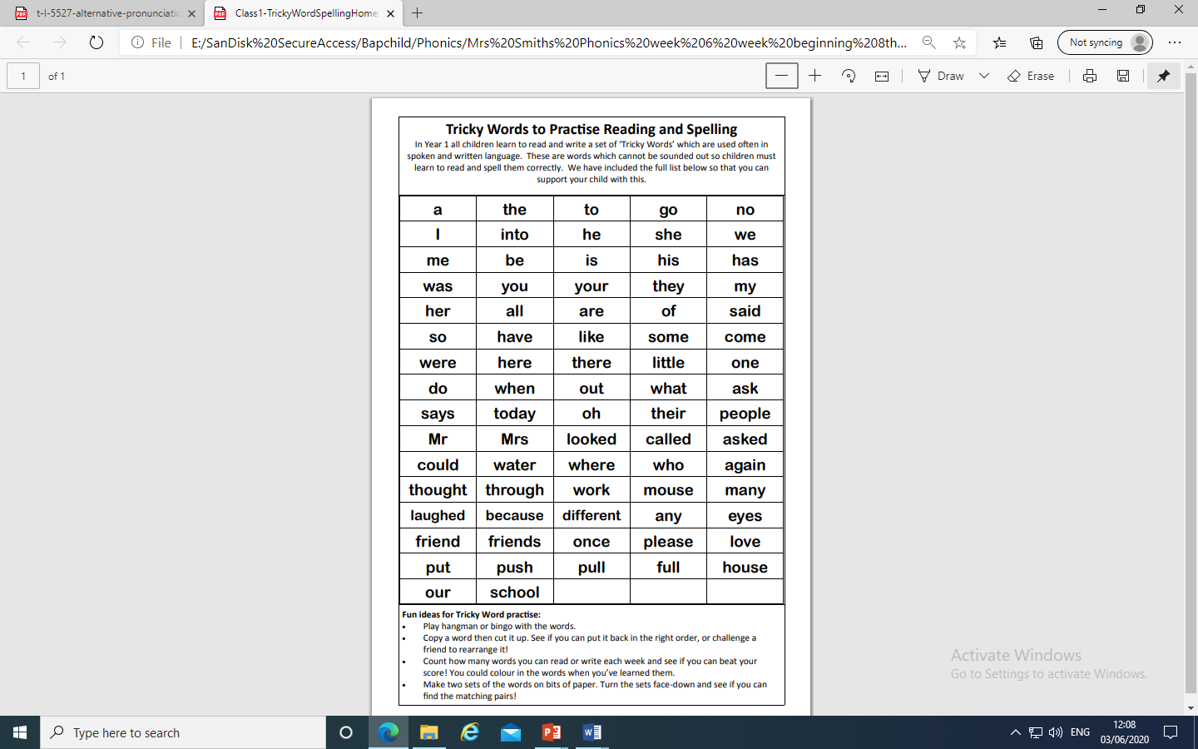

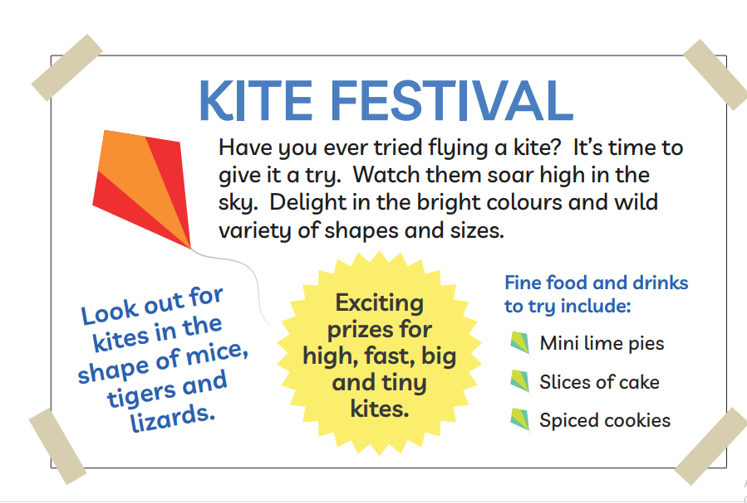
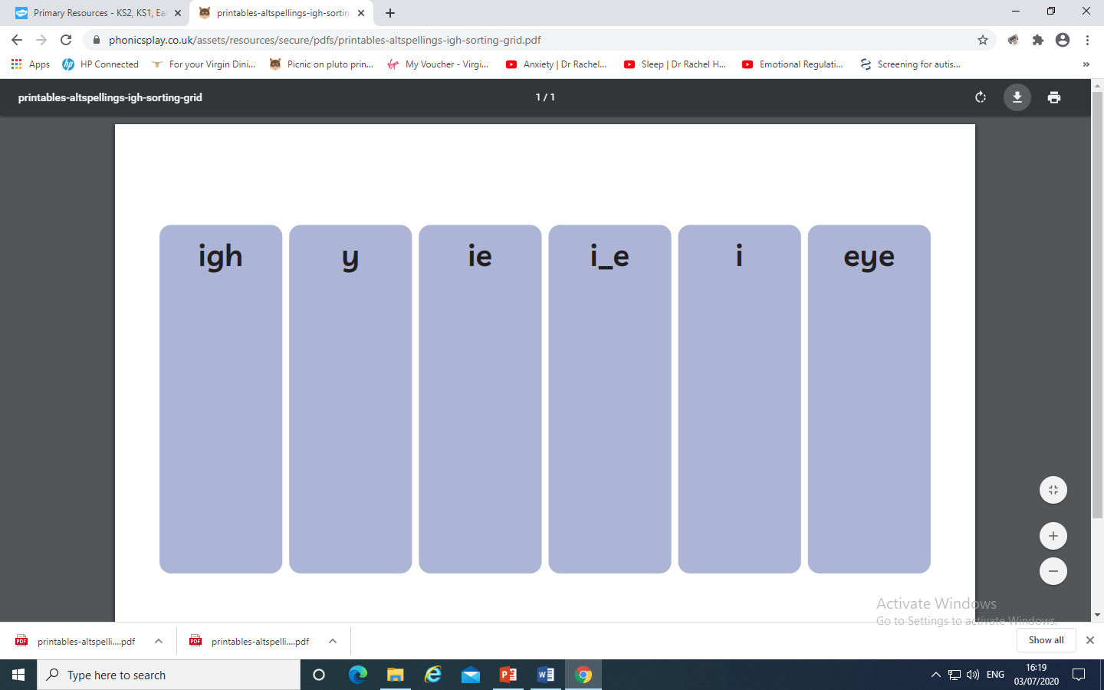
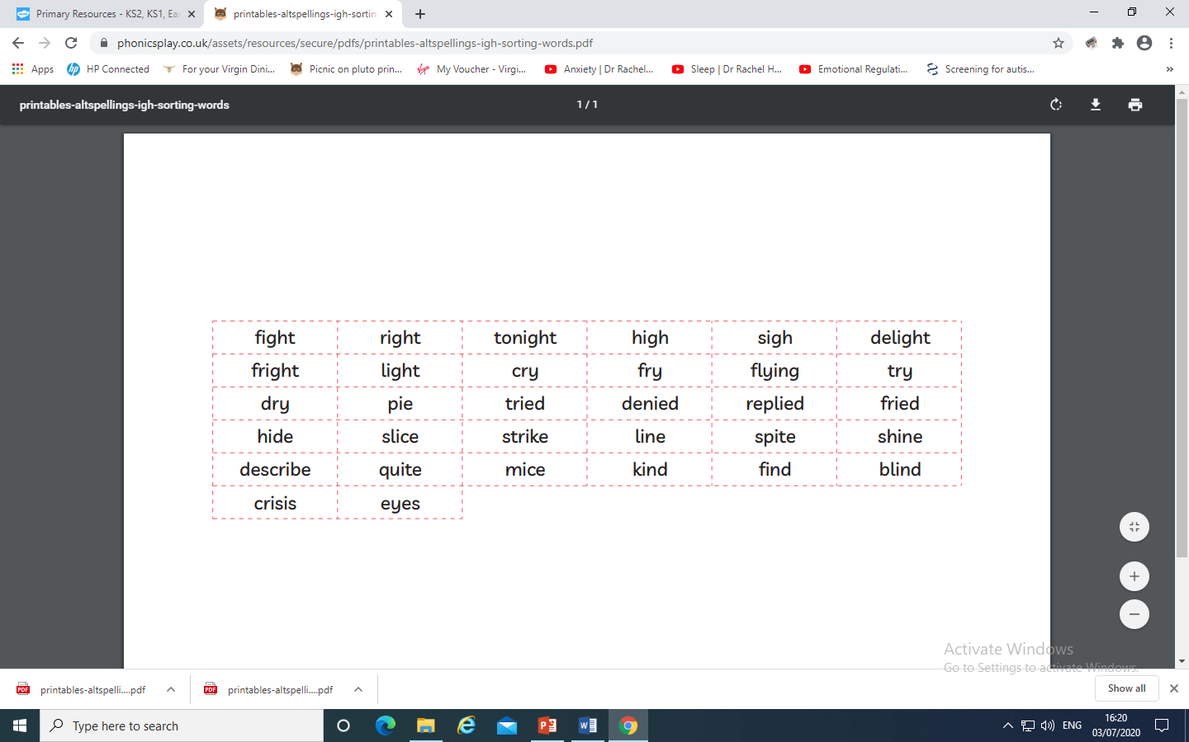
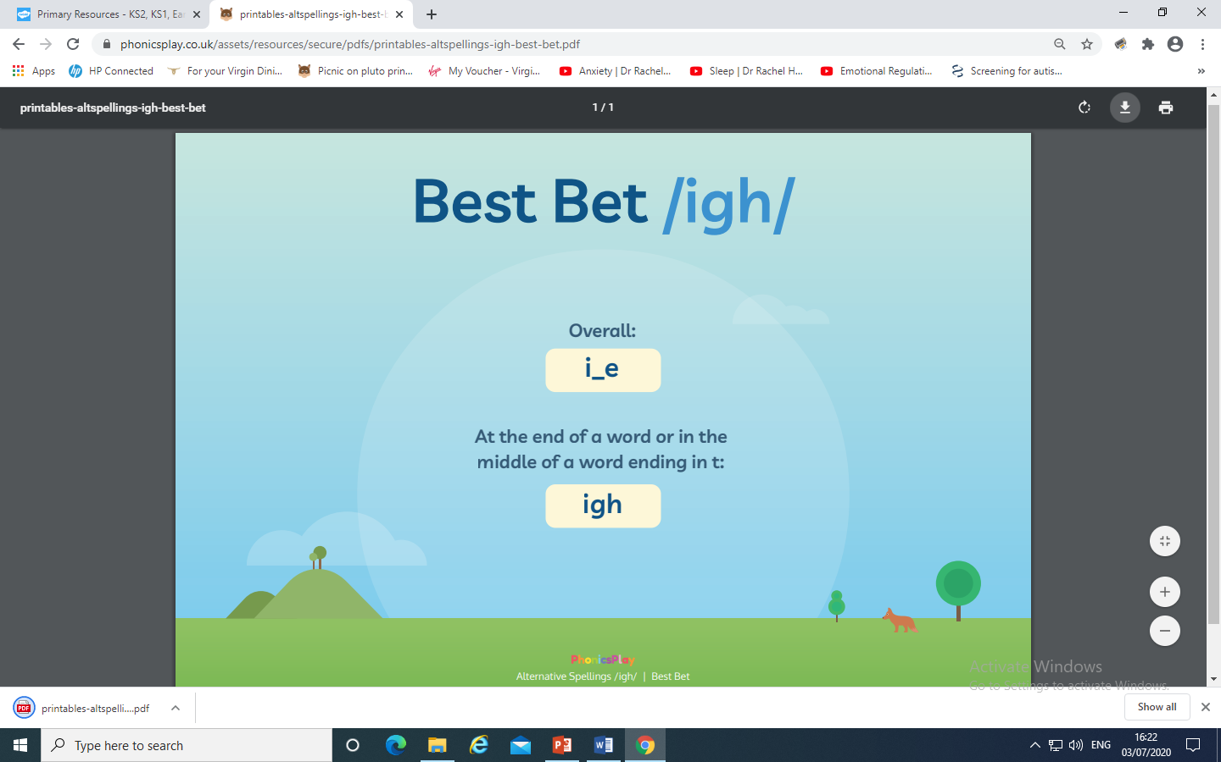
night | bright | fight | kite
bite | sight | light | pie
lie | tie | cried | tried
spied | fried | replied | applied
denied | by | my | try
why | dry | sky | spy
deny | reply | like | time
prize | shine | slide | pine
ripe | nice | decide | polite
right | tonight | high | sigh
delight | fright | flying | spite
mice | quite | describe | strike
line | kind | find | blind
crisis | eyes

ie
eye

igh

i-e

i
y

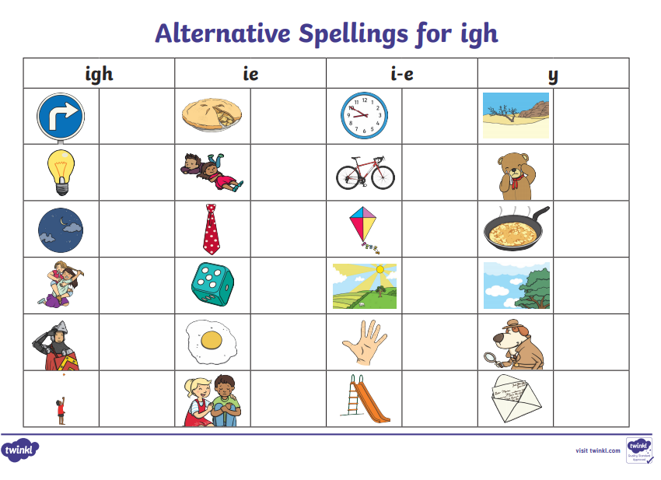

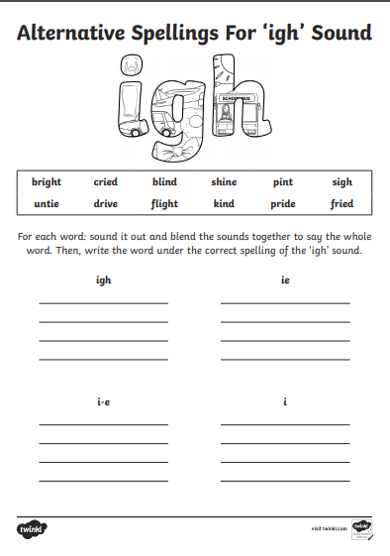
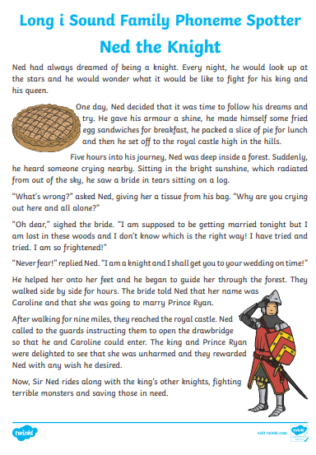
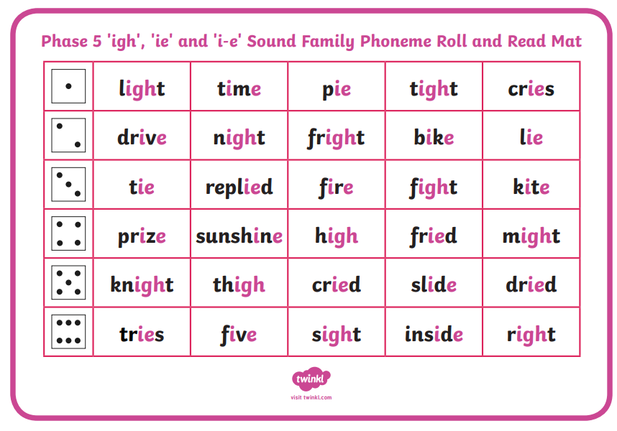
Alternative spellings for f…
f | ff | ph | gh

