ng | d | oa | er | i | ee | sh
a | ch | oo | c | oi | ure | e
u | r | air | b | f | ff | l
y | ss | j | qu | w | x | ll
z | zz | v | g | m | th | s
ai | n | igh | t | o | ur | or
or | ow | k | ear | h | k | p
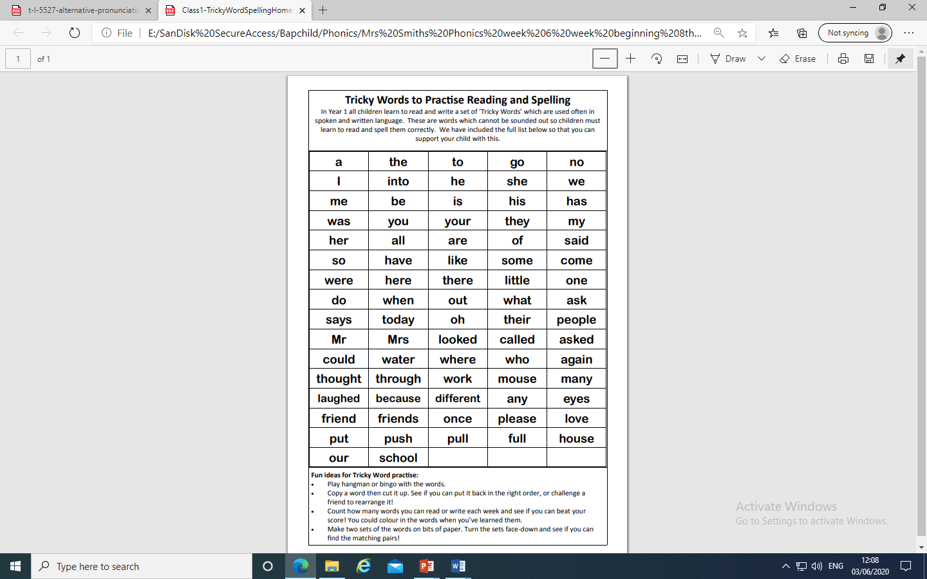

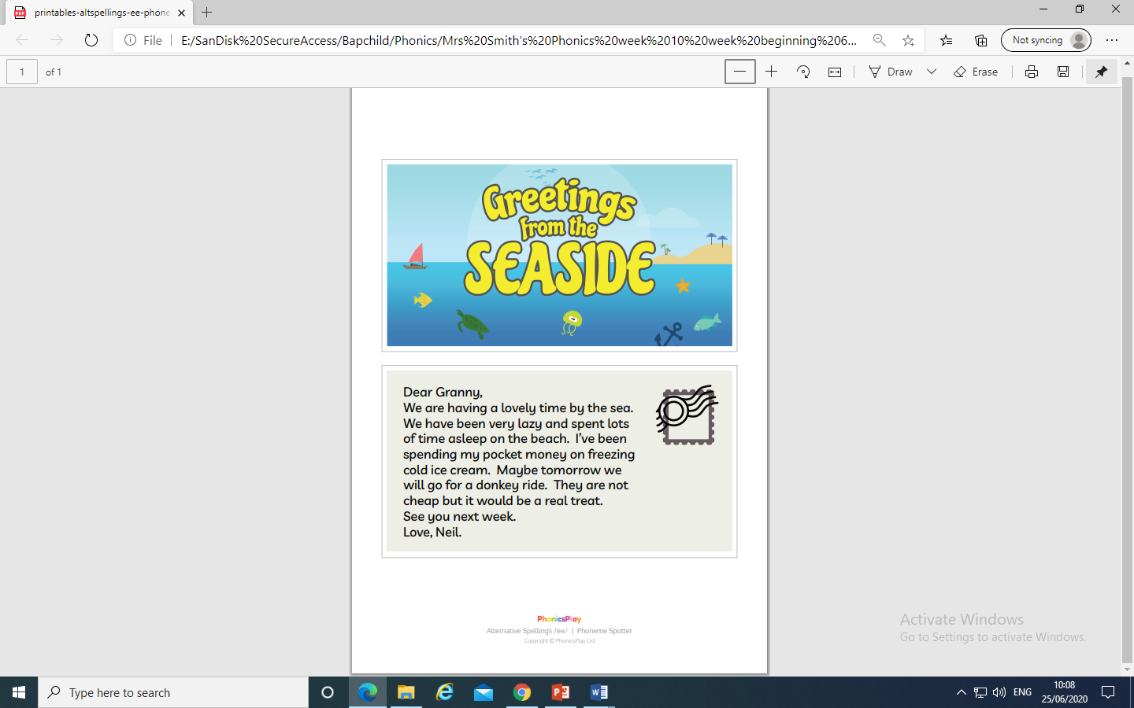
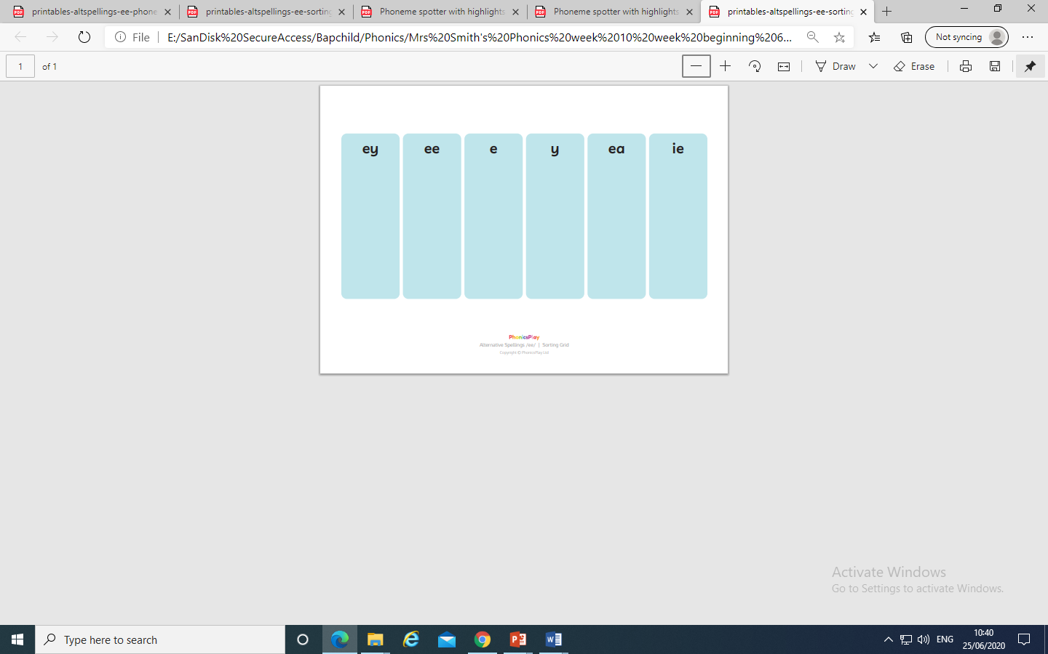
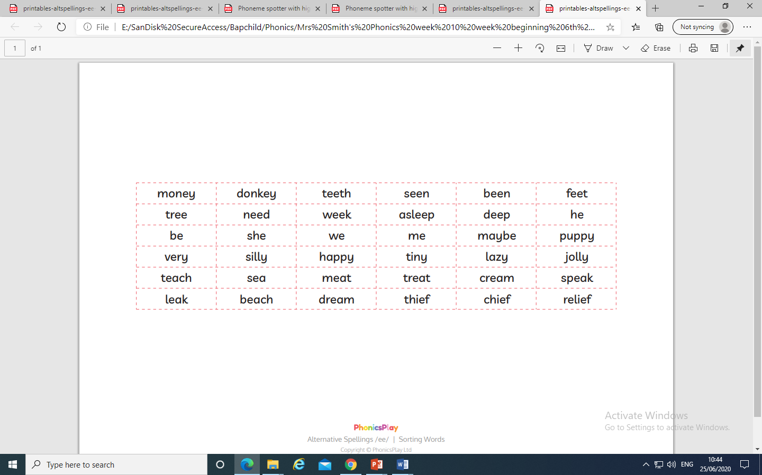

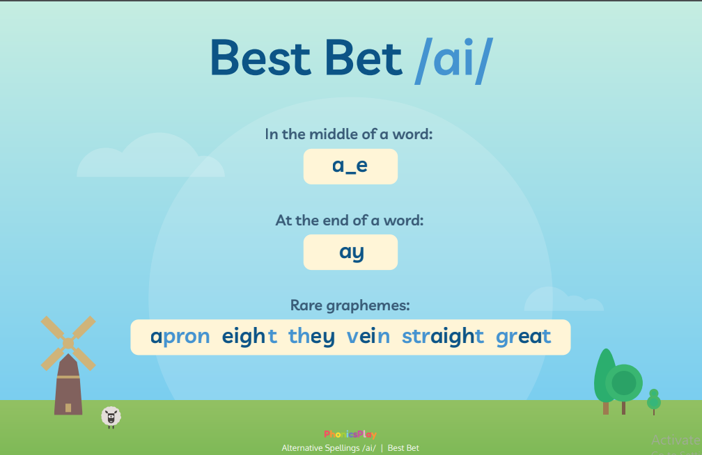

cheese | meet | treat | meat
seat | see | crazy | free
tree | bee | lazy | honey
donkey | cockney | jockey | turkey
chimney | valley | trolley | monkey
beans | been | feel | peel
jeep | seem | week | deep
bead | read | heap | least
steamy | repeat | these | Pete
Eve | Steve | even | theme
gene | scene | complete | extreme
he | me | she | we
be | recent | frequent | region
decent | happy | mummy | daddy
only | funny | sadly | penny
heavy | quickly | chief | brief
field | shield | priest | yield
shriek | thief | relief | belief
Marlene | complete | pulley | money
Lesley | cream | asleep | beach
Granny | lovely | freezing | maybe

ie

ea

e
e-e

ee
ey
y



