Somewhere Only We Know
Verse 1 - I walked across an empty land
I knew the pathway like the back of my hand
I felt the earth beneath my feet,
Sat by the river and it made me complete.
Oh simple thing, where have you gone?
I'm getting tired and I need someone to re-ly on………..
Verse 2 - I came across a fallen tree
I felt the branches of it looking at me
Is this the place we used to love?
Is this the place that I've been dreaming of?
HARMONY starts Oh simple thing, where have you gone?
I'm getting tired and I need someone to rely on
And if you have a minute, why don't we go
Talk about it somewhere only we know?
This could be the end of everything
So why don't we go somewhere only we know?
Unison Somewhere only we know…………….
AH……… (with glocks)
HARMONY resumes Oh simple thing, where have you gone?
I'm getting tired and I need someone to rely on
So tell me when you gonna let me in
I'm getting tired and I need somewhere to begin
And if you have a minute why don't we go
(rest)Talk about it somewhere only we know?
'Cause this could be the end of everything,
So why don't we go
slower! Somewhere only we know?
watch! Somewhere only we know?

Points where rehearsal may be necessary – for pitching / rubato

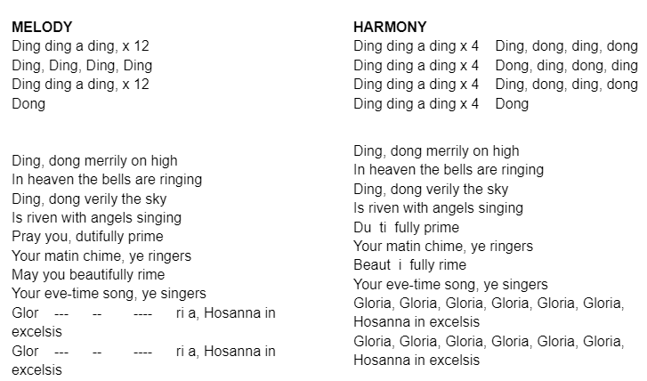
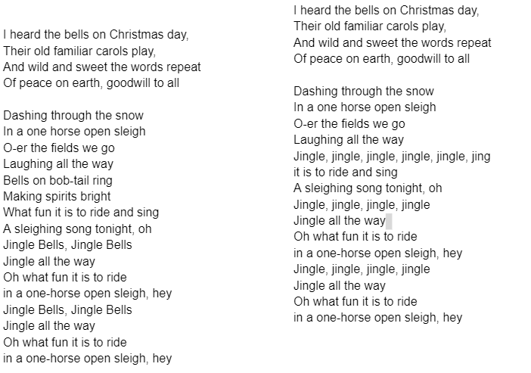

Christmas (Baby Please Come Home)  MELODY  I'm watching it fall  Lots of people around  Baby, please come home  Verse 1b  The church bells in town  All ringing in song  Full of happy sounds  Baby, please come home  Chorus  They're singing "Deck the Halls"  But it's not like Christmas at all  Gotta I remember when you were here  And all the fun we had last year  Verse 2  Pretty lights on the tree  I'm watching them shine  You should be here with me  Baby, please come home  Chorus  They're singing "Deck the Halls"  But it's not like Christmas at all  Gotta I remember when you were here  And all the fun we had last year  Verse 3  If there was a way  I'd hold back this tear  But it's Christmas day  Please, Please  Please, please, Please, please  Baby, please come home  Chorus x 2  Mary had a little baby  Intro  Verse 1  Mary had a little baby  Mary had a little baby,  Here and there and everywhere the angels sang  ‘Praise the Lord!’  Repeat Verse 1  Chorus- Glory, glory, glory, glory! Everybody sing the song  Glory, glory, glory, glory, God’s son has come to earth!  Repeat Verse 1  Instrumental (8 bars – modulate up 1)  Verse 2 - Mary, what you gonna call him?  Mary, what you gonna call him?  Here and there and everywhere the angels sang  ‘Praise the Lord!’  Verse 3 - Jesus, gonna call Him Jesus,  Jesus, gonna call Him Jesus,  Here and there and everywhere the angels sang  ‘Praise the Lord!’  Chorus- Glory, glory, glory, glory! Everybody sing the song  Glory, glory, glory, glory! God’s son has come to earth!  Repeat Verse 1  TWELVE DAYS OF CHRISTMAS  To learn the actions watch https://www.youtube.com/watch?v=nhL5Js2WE3c  START STRAIGHT AWAY!  On the first day of Christmas,  my true love sent to me  A partridge in a pear tree.  On the second day of Christmas,  my true love sent to me  Two turtle doves,  And a partridge in a pear tree.  On the third day of Christmas,  my true love sent to me  Three French hens,  Two turtle doves,  And a partridge in a pear tree.  On the fourth day of Christmas,  my true love sent to me  Four calling birds,  Three French hens,  Two turtle doves,  (All) And a partridge in a pear tree.  On the fifth day of Christmas,  my true love sent to me  Five golden rings,  Four calling birds,  Three French hens,  Two turtle doves,  And a partridge in a pear tree.  On the sixth day of Christmas,  my true love sent to me  Six geese a-laying,  Five golden rings,  Four calling birds,  Three French hens,  Two turtle doves,  And a partridge in a pear tree.  On the seventh day of Christmas,  my true love sent to me  Seven swans a-swimming,  Six geese a-laying,  Five golden rings,  Four calling birds,  Three French hens,  Two turtle doves,  (All) And a partridge in a pear tree.  On the eighth day of Christmas,  my true love sent to me  Eight maids a-milking,  Seven swans a-swimming,  Six geese a-laying,  Five golden rings,  Four calling birds,  Three French hens,  Two turtle doves,  (All) And a partridge in a pear tree.  On the ninth day of Christmas,  my true love sent to me  Nine ladies dancing,  Eight maids a-milking,  Seven swans a-swimming,  Six geese a-laying,  Five golden rings,  Four calling birds,  Three French hens,  Two turtle doves,  (All) And a partridge in a pear tree.  On the tenth day of Christmas,  my true love sent to me  Ten lords a-leaping,  Nine ladies dancing,  Eight maids a-milking,  Seven swans a-swimming,  Six geese a-laying,  Five golden rings,  Four calling birds,  Three French hens,  Two turtle doves,  (All) And a partridge in a pear tree.  On the eleventh day of Christmas,  my true love sent to me  Eleven pipers piping,  Ten lords a-leaping,  Nine ladies dancing,  Eight maids a-milking,  Seven swans a-swimming,  Six geese a-laying,  Five golden rings,  Four calling birds,  Three French hens,  Two turtle doves,  (All) And a partridge in a pear tree.  (All sing) On the twelfth day of Christmas,  my true love sent to me  Twelve drummers drumming, (4)  Eleven pipers piping, (2)  Ten lords a-leaping,  Nine ladies dancing,  Eight maids a-milking,  Seven swans a-swimming,  Six geese a-laying,  Five golden rings,  Four calling birds,  Three French hens,  Two turtle doves,  And a partridge in a pear tree! | HARMONY  Christmas  Christmas  Christmas  Christmas  Christmas  Christmas  Christmas  Christmas  Christmas  Christmas  Christmas  Christmas  Christmas  Christmas  Christmas  Christmas  Christmas  Christmas  Christmas  Christmas  Christmas  Christmas  Christmas  Please, Please  Please x 10

